CASE STUDY ON

AMAZON COGNITO



**INTRODUCTION**

Amazon Cognito provides authentication, authorization, and user management for your web and mobile apps.

Your users can sign in directly with a username and password, or through a third party such as Facebook, Amazon, Google or Apple.

The two main components of Amazon Cognito are user pools and identity pools. User pools are user directories that provide sign-up and sign-in options for your app users. Identity pools enable you to grant your users access to other AWS services. You can use identity pools and user pools separately or together.

# An Amazon Cognito user pool and identity pool used

**together**

See the diagram for a common Amazon Cognito scenario. Here the goal is to authenticate your user, and then grant your user access to another AWS service.

1. In the first step your app user signs in through a user pool and receives user pool tokens after a successful authentication.
2. Next, your app exchanges the user pool tokens for AWS credentials through an identity pool.
3. Finally, your app user can then use those AWS credentials to access other AWS services such as Amazon S3 or DynamoDB.

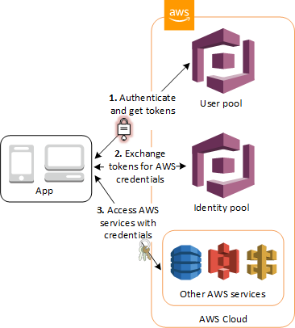

**HANDS ON**

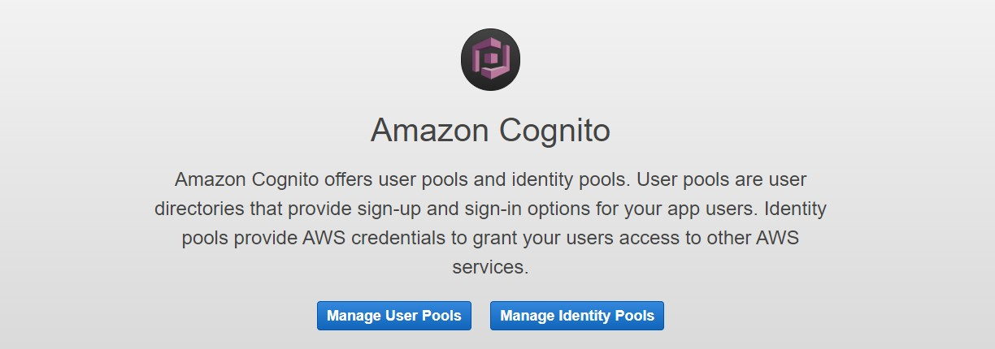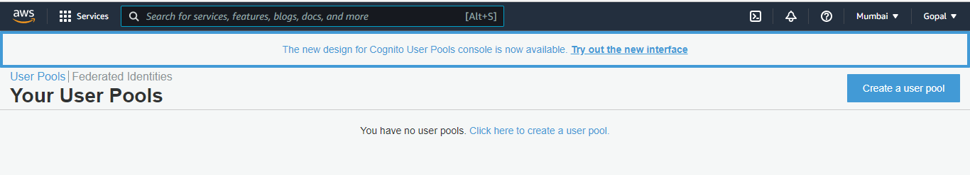

**Step 1:** Search **cognito** in the search bar. Then click on **manage user** pools. After that click on **create user pool,** then give **pool name** and click on **steps through setting.**

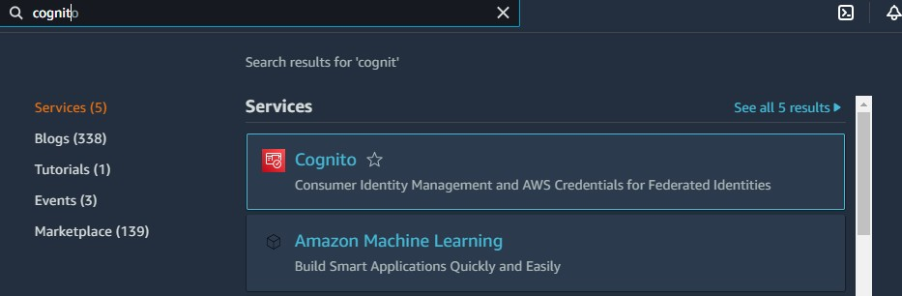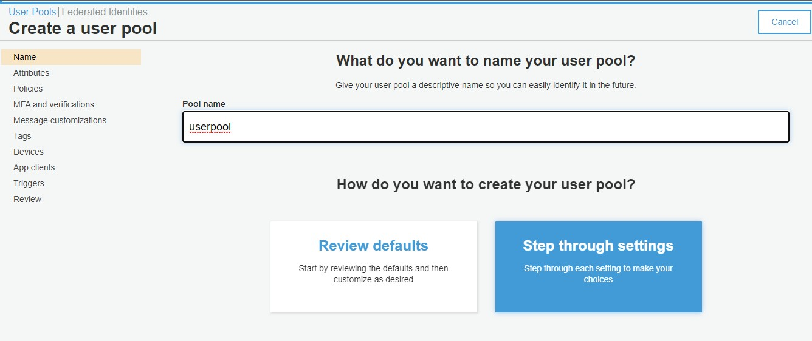

**Step 2:** Keep all things as default or you can choose as per your requirement.

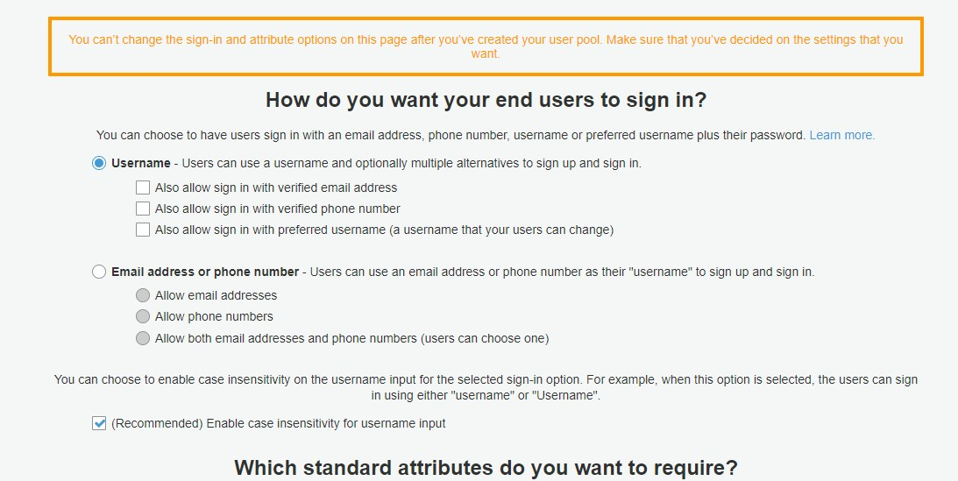

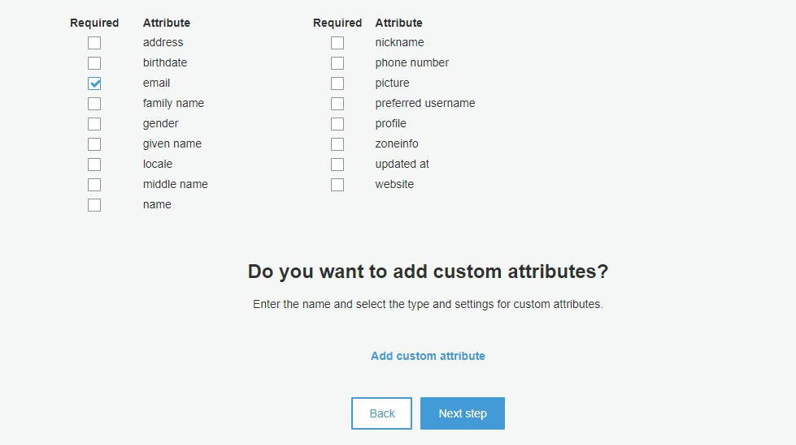

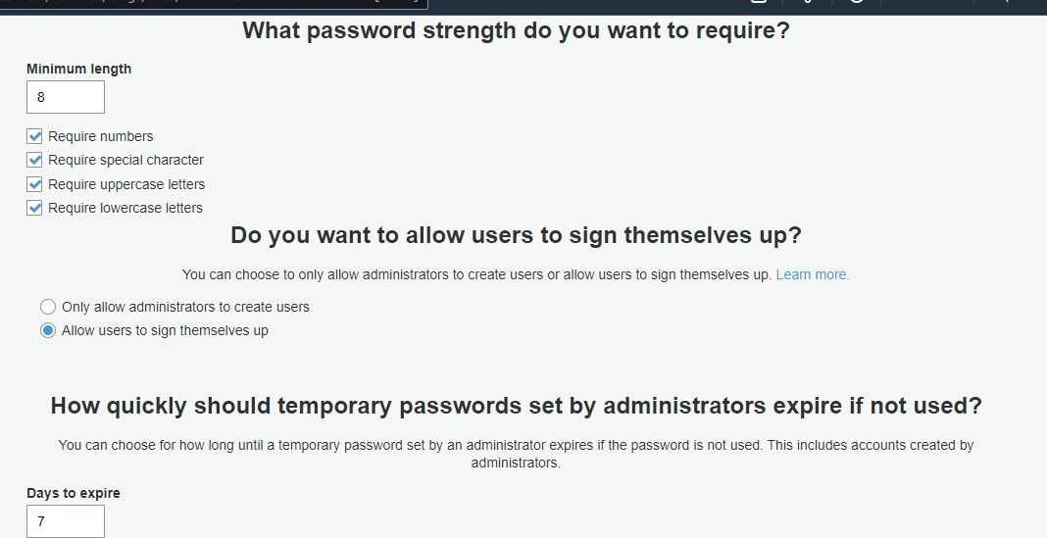**Step 3:** Next step is how strong you want the password during signup process. You can setup here or keep as default.

**Step 4:** now we can enable MFA here but for the demo

purpose I am keeping all thing as default.

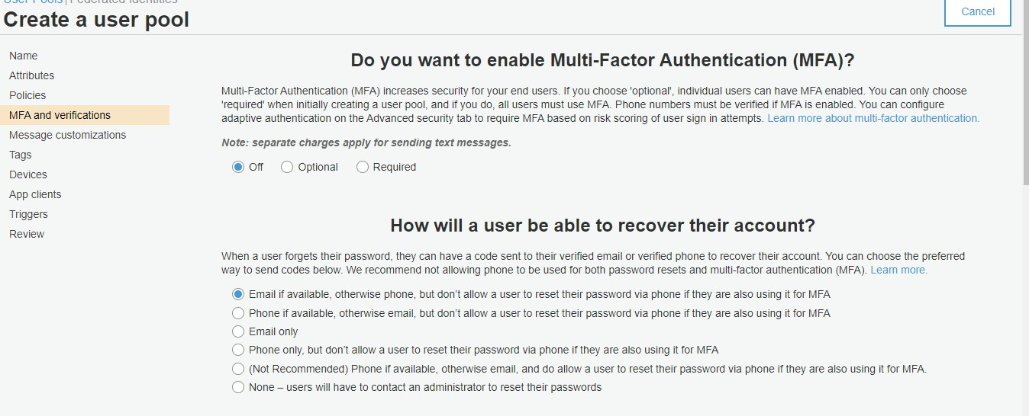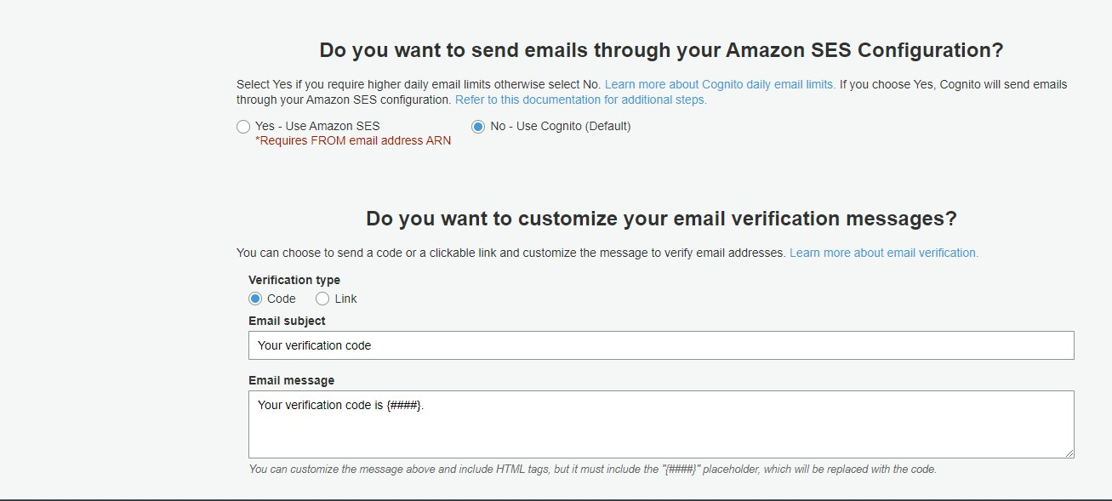

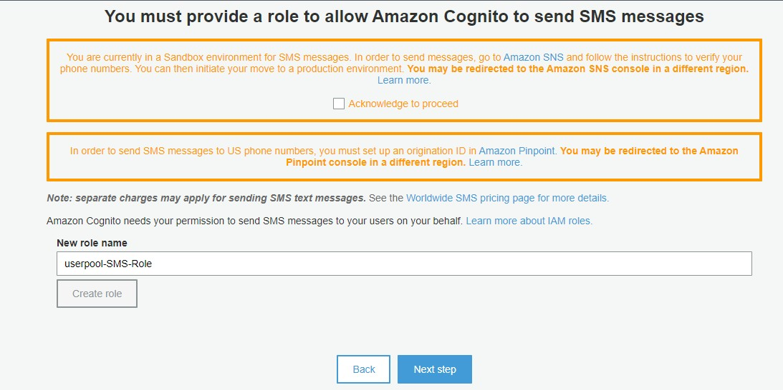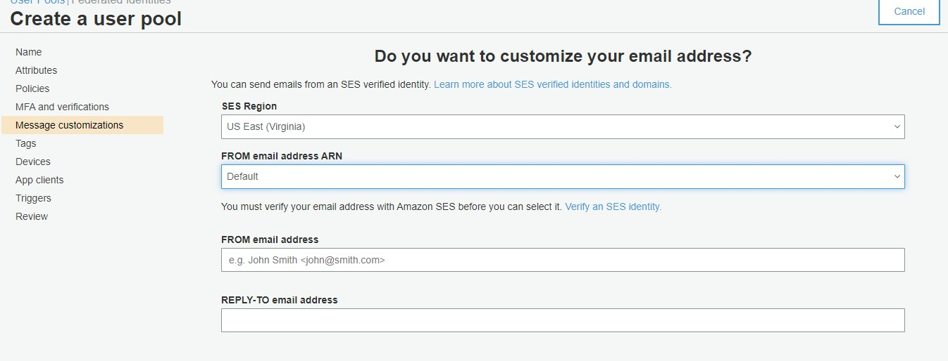

**Step 5:** now we can customize your invitation messages but for the demo purpose I am keeping all thing as default.

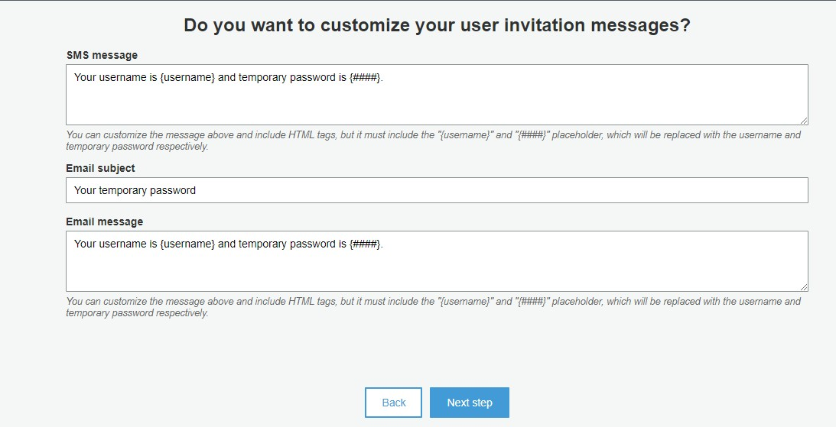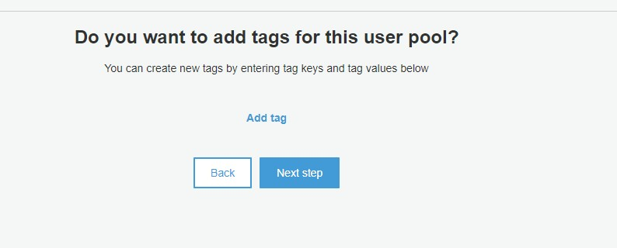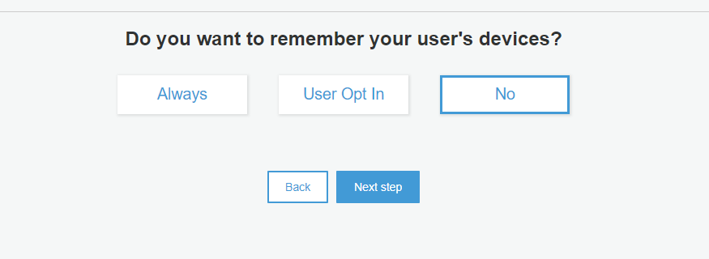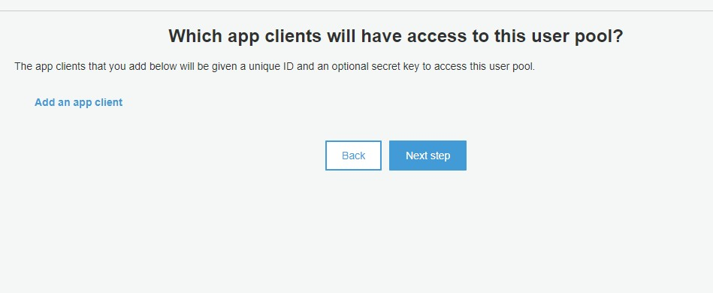

**Step 6:** we can add triggers here but for the demo

purpose I am keeping all thing as default.

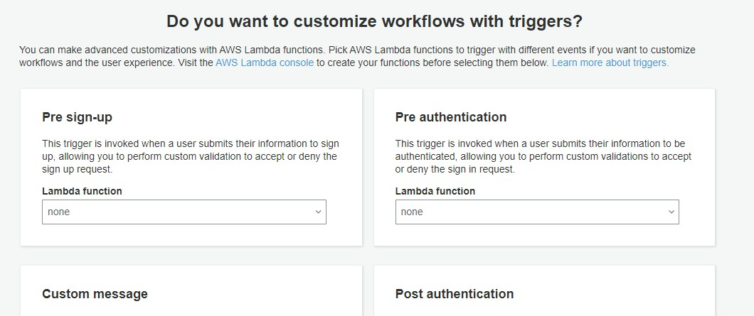

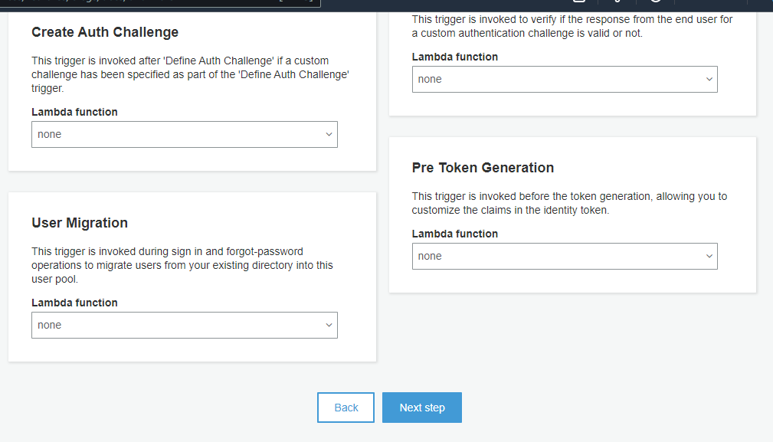

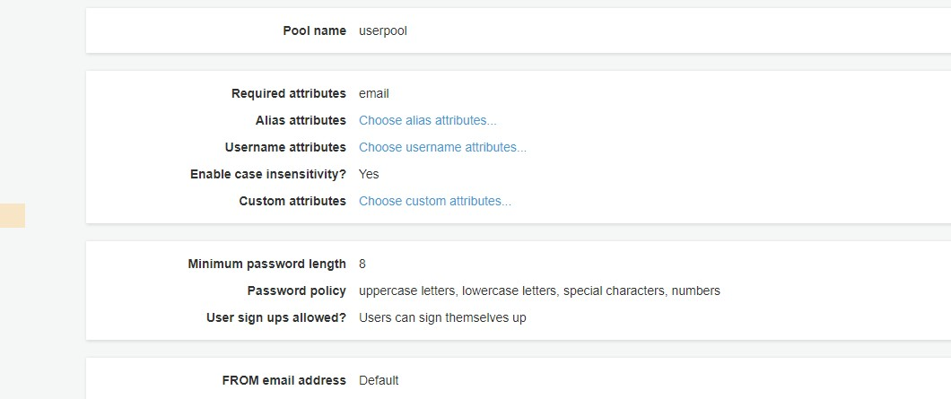

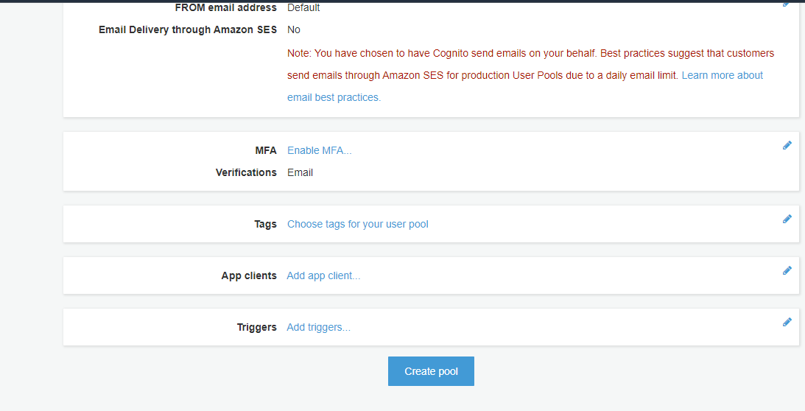

**Step 7:** we have to define domain name now. Click domain name on left side then give domain name in the box and check for availability.

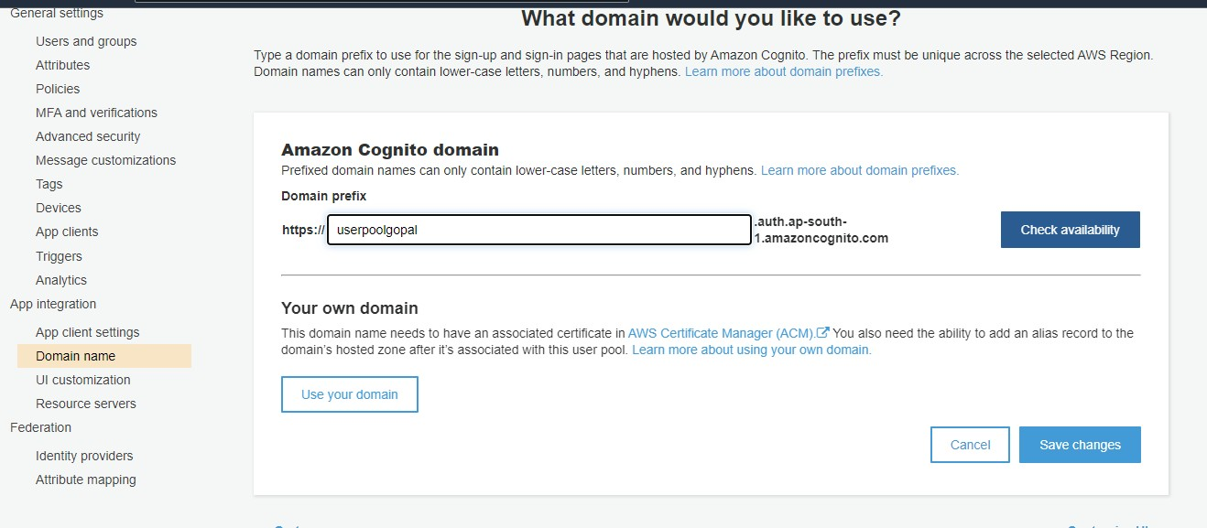

**Step 8:** if it available you can see it then **save changes**

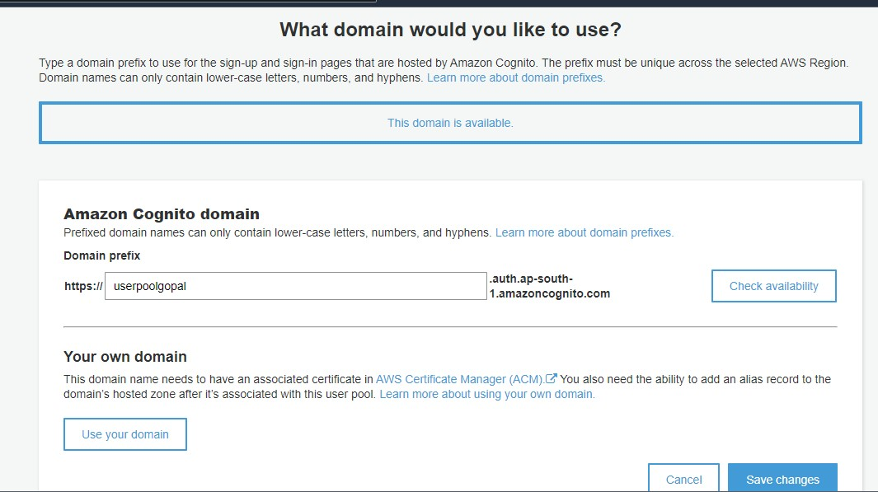

**Step 9:** add clients now . Follow the marked steps.

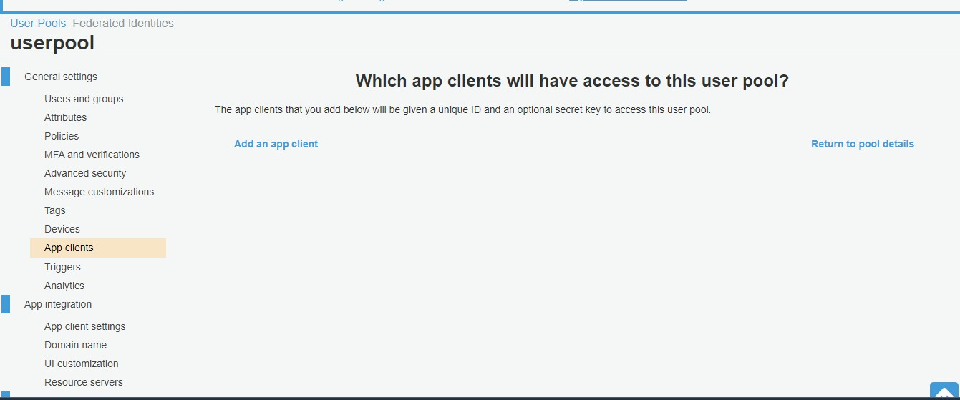

**Step 10:** Give app client name , uncheck the generate client secret and mark down the below check box as per your requirement

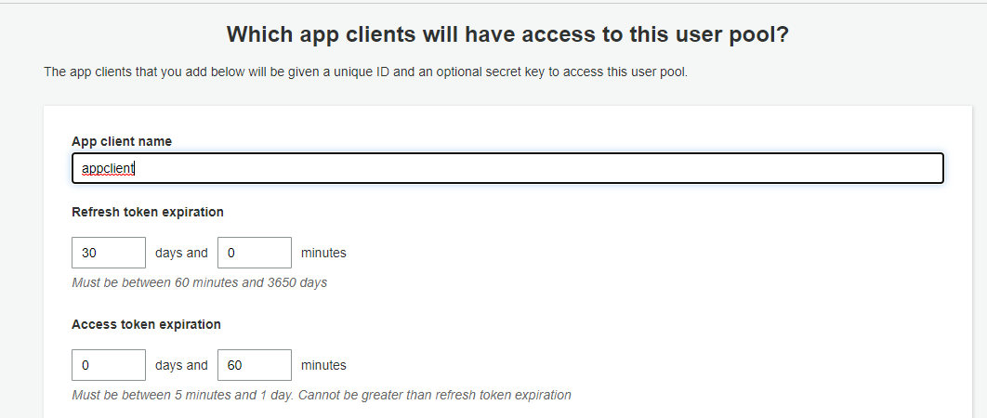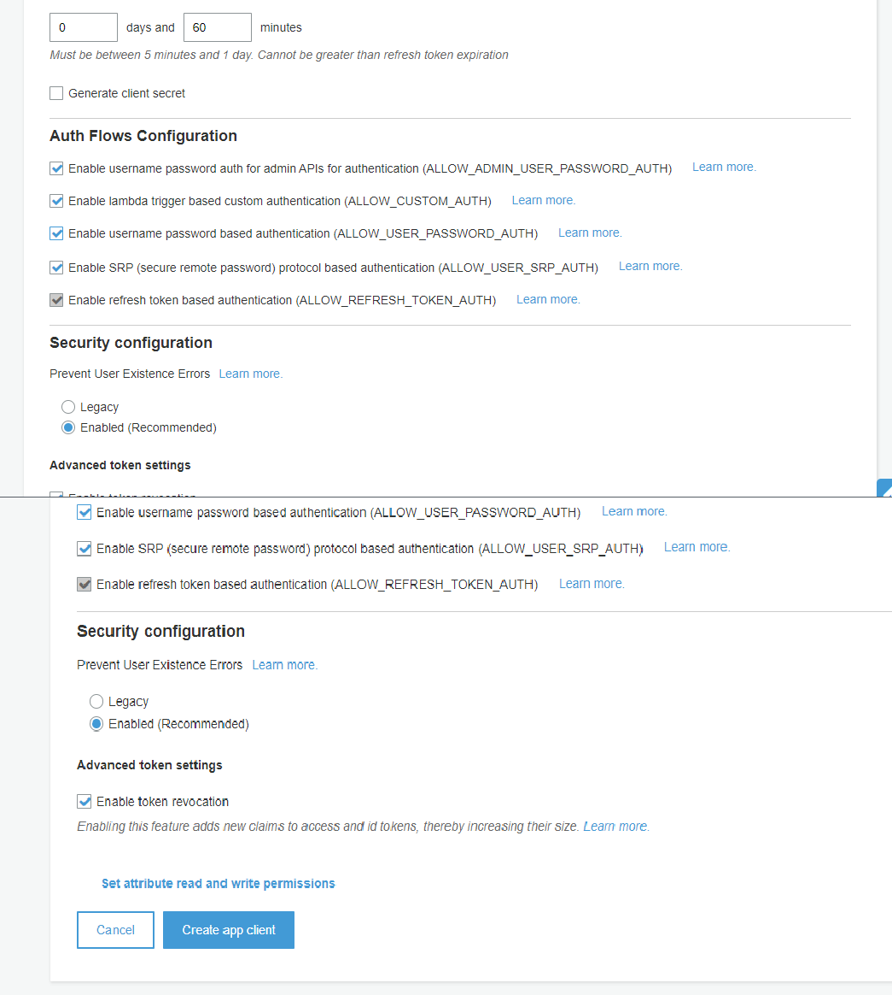

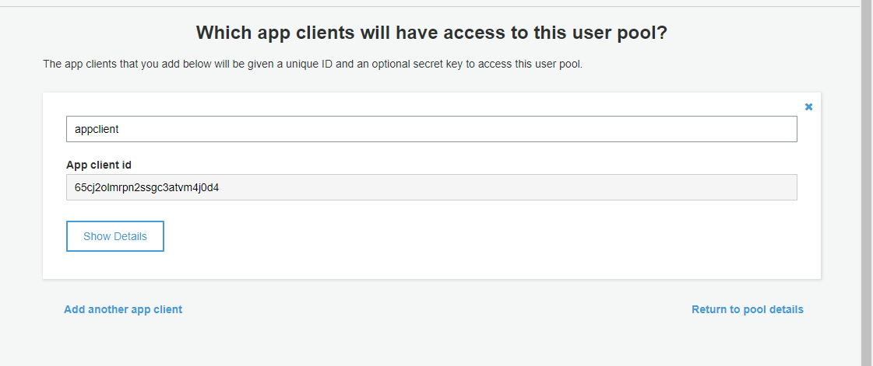

**Step 11:** Now click on **App client settings** the check

**select all**

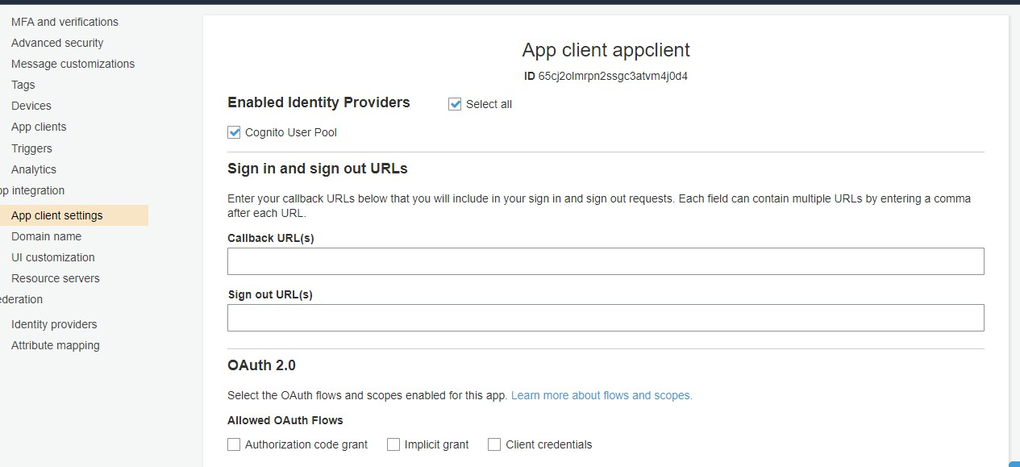

**Step 12:** Give sign in and sign out URL check mark the below checks and click on save changes

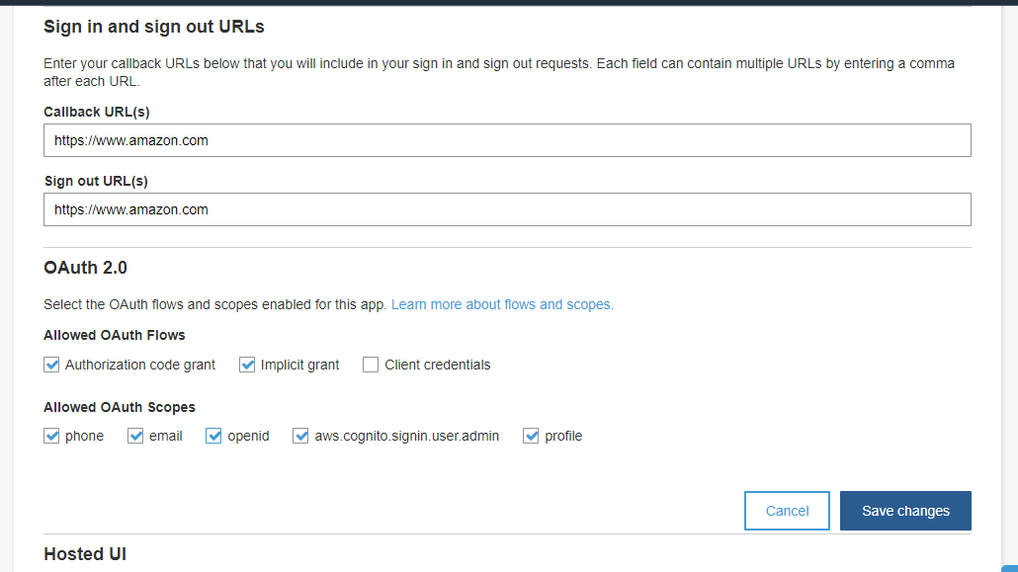

**Step 13:** once you click **save changes** below interface will appear now click on **launch hosted UI**

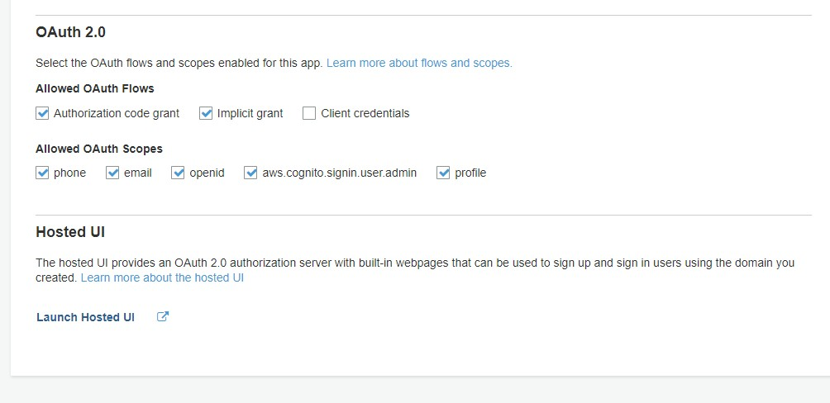

**Step 14:** You will be redirected to this page and if you are new user try sing up and verification code will be sent to you email .

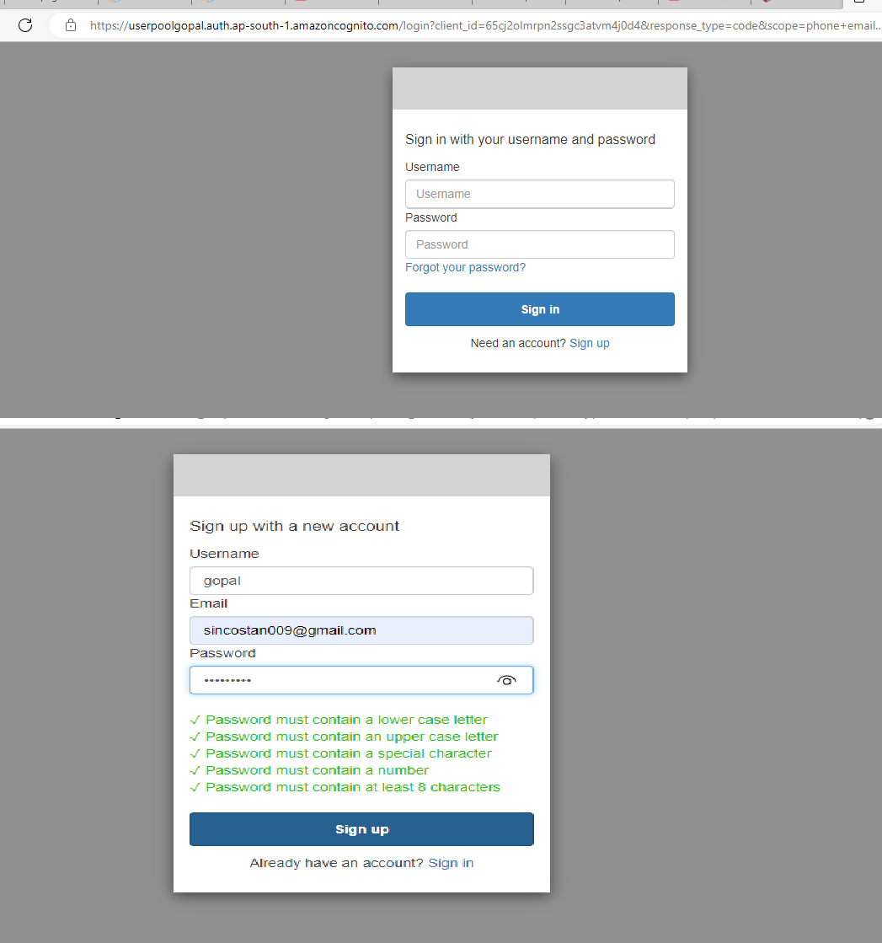

**Step 15:** Once you enter correct verification code you will be redirected to amazon.com

